Operating System Lab Final Task

Submitted by -

ID:
Section: D
Batch - 12

Part 1: CPU Scheduling Simulation
Code:

#include <iostream>
#include <vector>
#include <queue>
#include <algorithm>
using namespace std;
struct Process {
int pid, arrival, burst, remaining;
int completion, waiting, turnaround;
};
void printResults(vector<Process> p) {
float totalWT = 0, totalTAT = 0;
cout << "\n PID \t AT \t BT \t WT \t TAT \n";
for (auto &proc : p) {
cout << "P" << proc.pid << "\t"
<< proc.arrival << "\t"
<< proc.burst << "\t"
<< proc.waiting << "\t"
<< proc.turnaround << "\n";
totalWT += proc.waiting;
totalTAT += proc.turnaround;
}
cout << "\nAverage Waiting Time: " << totalWT / p.size();
cout << "\nAverage Turnaround Time: " << totalTAT / p.size() << "\n";
}
void fcfs(vector<Process> p) {
cout << "\n===== FCFS Scheduling =====\n";
sort(p.begin(), p.end(), [](Process a, Process b) {
return a.arrival < b.arrival;
});
int time = 0;
cout << "\n Gantt Chart: \n| ";
for (auto &proc : p) {
if (time < proc.arrival)
time = proc.arrival;
cout << "P" << proc.pid << " | ";
time += proc.burst;
proc.completion = time;
proc.turnaround = proc.completion - proc.arrival;
proc.waiting = proc.turnaround - proc.burst;
}
cout << "\n";
printResults(p);
}
void sjf(vector<Process> p) {
cout << "\n===== SJF Scheduling =====\n";
int n = p.size();
int completed = 0, time = 0;
vector<bool> done(n, false);
cout << "\n Gantt Chart: \n| ";
while (completed < n) {
int idx = -1;
int minBurst = 1e9;
for (int i = 0; i < n; i++) {
if (!done[i] && p[i].arrival <= time && p[i].burst < minBurst) {
minBurst = p[i].burst;
idx = i;
}
}
if (idx == -1) {
time++;
continue;
}
cout << "P" << p[idx].pid << " | ";
time += p[idx].burst;
p[idx].completion = time;
p[idx].turnaround = p[idx].completion - p[idx].arrival;
p[idx].waiting = p[idx].turnaround - p[idx].burst;
done[idx] = true;
completed++;
}
cout << "\n";
printResults(p);
}
void roundRobin(vector<Process> p, int quantum) {
cout << "\n===== Round Robin Scheduling =====\n";
int n = p.size();
queue<int> q;
int time = 0, completed = 0;
sort(p.begin(), p.end(), [](Process a, Process b) {
return a.arrival < b.arrival;
});
for (int i = 0; i < n; i++)
p[i].remaining = p[i].burst;
int i = 0;
cout << "\n Gantt Chart: \n| ";
while (completed < n) {
while (i < n && p[i].arrival <= time) {
q.push(i);
i++;
}
if (q.empty()) {
time++;
continue;
}
int idx = q.front();
q.pop();
cout << "P" << p[idx].pid << " | ";
if (p[idx].remaining > quantum) {
time += quantum;
p[idx].remaining -= quantum;
} else {
time += p[idx].remaining;
p[idx].remaining = 0;
p[idx].completion = time;
p[idx].turnaround = p[idx].completion - p[idx].arrival;
p[idx].waiting = p[idx].turnaround - p[idx].burst;
completed++;
}
while (i < n && p[i].arrival <= time) {
q.push(i);
i++;
}
if (p[idx].remaining > 0)
q.push(idx);
}
cout << "\n";
printResults(p); }
int main() {
int n;
cout << "Enter number of processes: ";
cin >> n;
vector<Process> p(n);
for (int i = 0; i < n; i++) {
p[i].pid = i + 1;
cout << "Enter Arrival Time for P" << i + 1 << ": ";
cin >> p[i].arrival;
cout << "Enter Burst Time for P" << i + 1 << ": ";
cin >> p[i].burst; }
int quantum;
cout << "Enter Time Quantum for Round Robin: ";
cin >> quantum;
fcfs(p);
sjf(p);
roundRobin(p, quantum);
return 0; }

Screenshot:
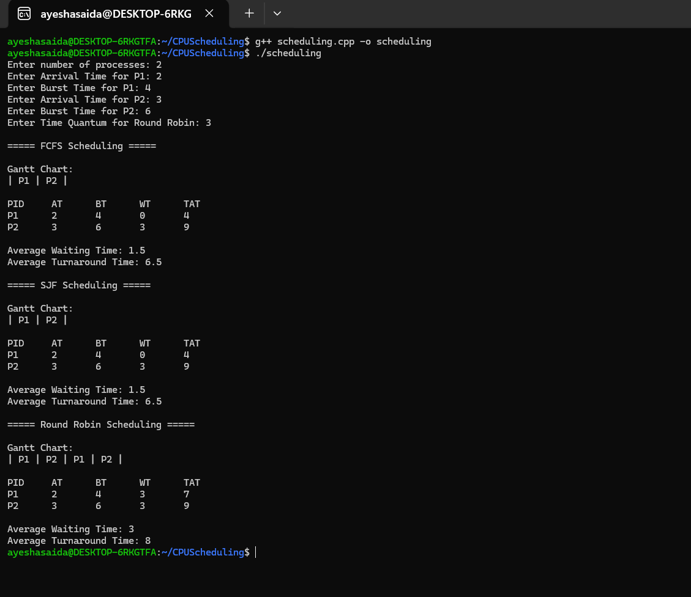

Part 2: Deadlock Detection & Avoidance
Section A: Banker's Algorithm (Deadlock Avoidance)
Part - 2: Deadlock Detection & Avoidance
Section A: Banker's Algorithm (Deadlock Avoidance)
Code:

#include <iostream>
using namespace std;
int main() {
int n, m;
cout << "Enter number of processes: ";
cin >> n;
cout << "Enter number of resource types: ";
cin >> m;
int alloc[n][m], max[n][m], avail[m], need[n][m];
cout << "\n Enter Allocation Matrix: \n";
for(int i = 0; i < n; i++) {
for(int j = 0; j < m; j++) {
cin >> alloc[i][j]; } }
cout << "\n Enter Maximum Matrix: \n";
for(int i = 0; i < n; i++) {
for(int j = 0; j < m; j++) {
cin >> max[i][j]; } }
cout << "\n Enter Available Resources: \n";
for(int j = 0; j < m; j++) {
cin >> avail[j]; }

// Calculate Need matrix

for(int i = 0; i < n; i++) {
for(int j = 0; j < m; j++) {
need[i][j] = max[i][j] - alloc[i][j]; } }
bool finish[n] = {false};
int safeSeq[n];
int work[m];
for(int i = 0; i < m; i++)
work[i] = avail[i];
int count = 0;
while(count < n) {
bool found = false;
for(int i = 0; i < n; i++) {
if(!finish[i]) {
bool possible = true;
for(int j = 0; j < m; j++) {
if(need[i][j] > work[j]) {
possible = false;
break; } }
if(possible) {
for(int j = 0; j < m; j++)
work[j] += alloc[i][j];
safeSeq[count++] = i;
finish[i] = true;
found = true; } } }
if(!found) {
cout << "\n System is in UNSAFE state! Deadlock may occur. \n";
return 0; } }
cout << "\n System is in SAFE state.\n Safe Sequence: ";
for(int i = 0; i < n; i++)
cout << "P" << safeSeq[i] << " ";
cout << endl;
return 0;
}

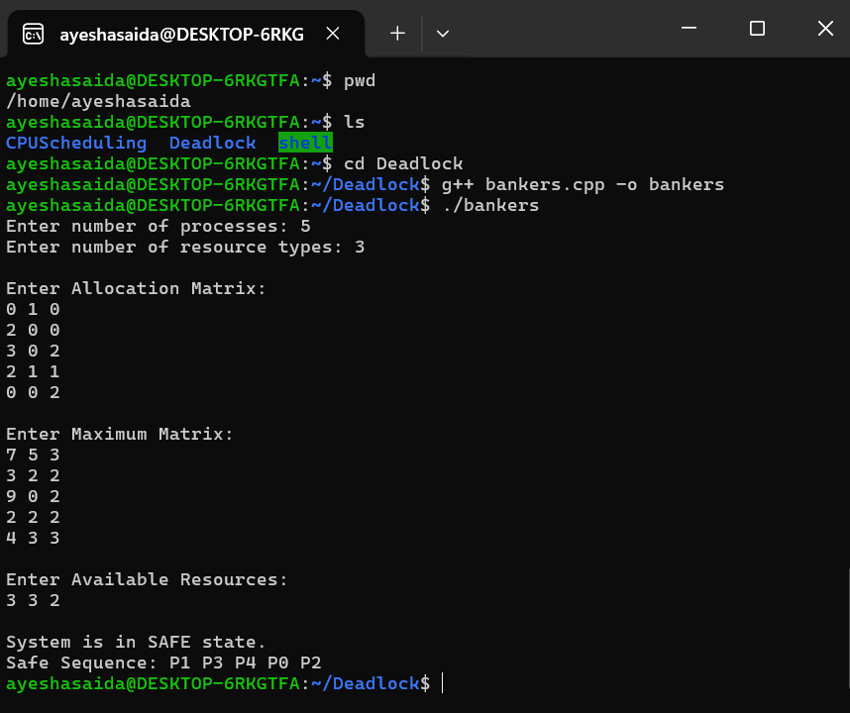
Screenshot:

Section - B: Deadlock Creation Using Threads
Code:

#include <iostream>
#include <thread>
#include <mutex>
#include <chrono>
using namespace std;
// ----------------- Deadlock Demo -----------------
mutex deadlockA;
mutex deadlockB;
void deadlock_thread1() {
cout << "[Deadlock] Thread 1: Trying to lock Resource A" << endl;
cout << "[Deadlock] Thread 1: Locked Resource A" << endl;
this_thread::sleep_for(chrono::milliseconds(100));
cout << "[Deadlock] Thread 1: Trying to lock Resource B" << endl;
}
void deadlock_thread2() {
cout << "[Deadlock] Thread 2: Trying to lock Resource B" << endl;
cout << "[Deadlock] Thread 2: Locked Resource B" << endl;
this_thread::sleep_for(chrono::milliseconds(100));
cout << "[Deadlock] Thread 2: Trying to lock Resource A" << endl;
}
// ----------------- Fixed Version -----------------
mutex fixedA;
mutex fixedB;
void fixed_thread1() {
cout << "[Fixed] Thread 1: Trying to lock Resource A" << endl;
fixedA.lock();
cout << "[Fixed] Thread 1: Locked Resource A" << endl;
this_thread::sleep_for(chrono::milliseconds(100));
cout << "[Fixed] Thread 1: Trying to lock Resource B" << endl;
fixedB.lock();
cout << "[Fixed] Thread 1: Locked Resource B" << endl;
fixedB.unlock();
fixedA.unlock(); }
void fixed_thread2() {
cout << "[Fixed] Thread 2: Trying to lock Resource A" << endl;
fixedA.lock();
cout << "[Fixed] Thread 2: Locked Resource A" << endl;
this_thread::sleep_for(chrono::milliseconds(100));
cout << "[Fixed] Thread 2: Trying to lock Resource B" << endl;
fixedB.lock();
cout << "[Fixed] Thread 2: Locked Resource B" << endl;
fixedB.unlock();
fixedA.unlock(); }
// ----------------- MAIN -----------------
int main() {
cout << "===== DEADLOCK DEMO =====" << endl;
thread t1(deadlock_thread1);
thread t2(deadlock_thread2);
t1.join();
t2.join();
cout << "Deadlock would occur here if threads fully locked resources." << endl;
cout << "\n===== FIXED VERSION =====" << endl;
thread f1(fixed_thread1);
thread f2(fixed_thread2);
f1.join();
f2.join();
cout << "Program finished successfully." << endl;
return 0;
}

Screenshot:
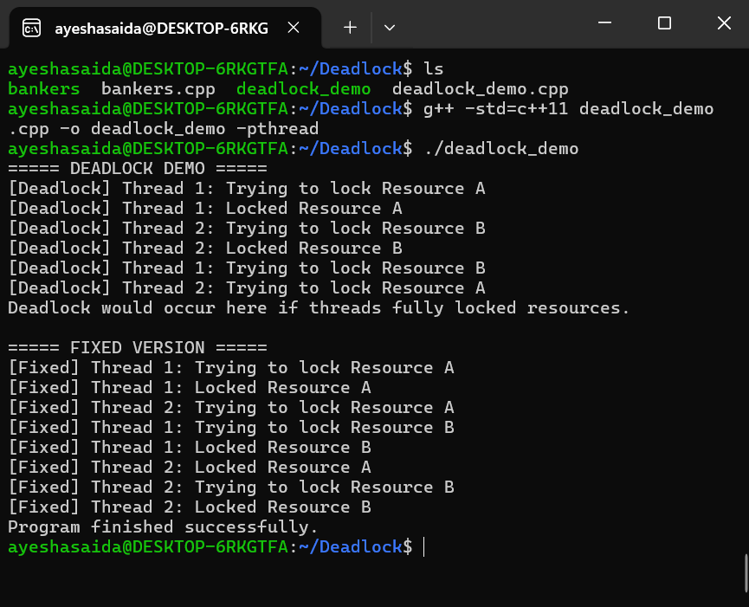

Part - 3: Threading and Synchronization
Task -1:
Code
Part 3: Threading and Synchronization
Task 1: Thread Creation
Code:

#include <iostream>
#include <thread>
#include <vector>
#include <numeric>

void threadTask(int threadNum, const std::vector<int>& arr, int start, int end) {

// Print the thread ID
std::thread::id this_id = std::this_thread::get_id();
std::cout << "Thread " << threadNum << " ID: " << this_id << std::endl;

// Perform sum computation on the array portion
int sum = 0;
for (int i = start; i < end; ++i) {
sum += arr[i]; }
std::cout << "Thread " << threadNum << " computed sum: " << sum << std::endl; }
int main() {
const int numThreads = 4;
const int arraySize = 16;

// Initialize an array with some values
std::vector<int> arr(arraySize);
for (int i = 0; i < arraySize; ++i) {
arr[i] = i + 1; }
std::vector<std::thread> threads;
int chunkSize = arraySize / numThreads;

// Create threads
for (int i = 0; i < numThreads; ++i) {
int start = i * chunkSize;
int end = (i == numThreads - 1) ? arraySize : start + chunkSize;
threads.push_back(std::thread(threadTask, i + 1, std::ref(arr), start, end));
}

// Join threads
for (auto& th : threads) {
th.join(); }
std::cout << "All threads completed." << std::endl;
return 0; }

Screenshot:
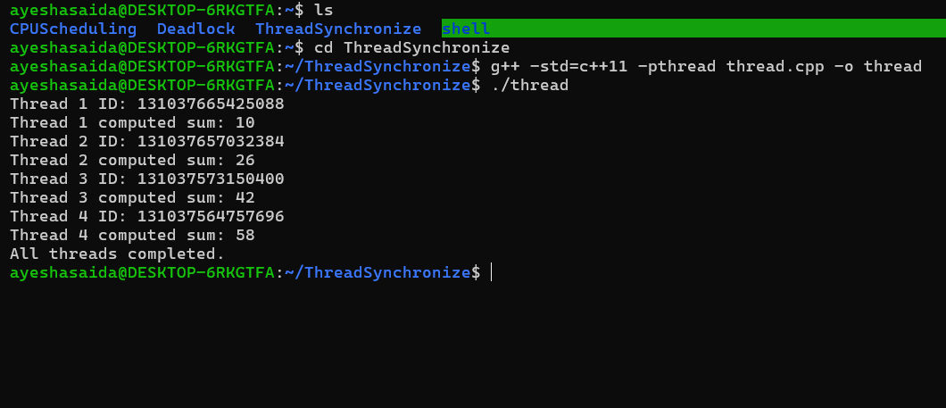

Task 2: Race Condition Demonstration
Code:

#include <iostream>
#include <thread>
#include <vector>
int counter = 0;
void incrementCounter() {
for (int i = 0; i < 10000; ++i) {
counter++; } }
int main() {
const int numThreads = 4;
std::vector<std::thread> threads;

// Create threads
for (int i = 0; i < numThreads; ++i) {
threads.push_back(std::thread(incrementCounter));
}

// Join all threads
for (auto& th : threads) {
th.join();
}

// Print final counter value
std::cout << "Expected final counter value: " << 4 * 10000 << std::endl;
std::cout << "Actual final counter value: " << counter << std::endl;
return 0; }

Screenshot:
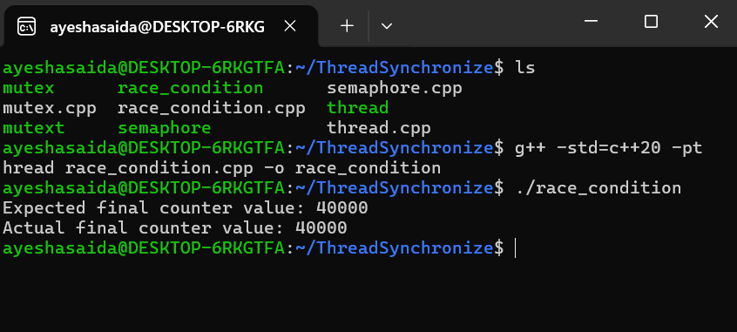

Task 3: Synchronization (Mutex & Semaphore)
Code: using mutex

#include <iostream>
#include <thread>
#include <vector>
#include <mutex>
int counter = 0; // Shared counter
std::mutex counterMutex; // Mutex for synchronization
void incrementCounterMutex() {
for (int i = 0; i < 10000; ++i) {
std::lock_guard<std::mutex> lock(counterMutex); // Lock mutex
counter++;
}
}
int main() {
const int numThreads = 5;
std::vector<std::thread> threads;
for (int i = 0; i < numThreads; ++i) {
threads.push_back(std::thread(incrementCounterMutex));
}
for (auto& th : threads) {
th.join();
}
std::cout << "Final counter value with mutex: " << counter << std::endl;
return 0;
}

Screenshot:
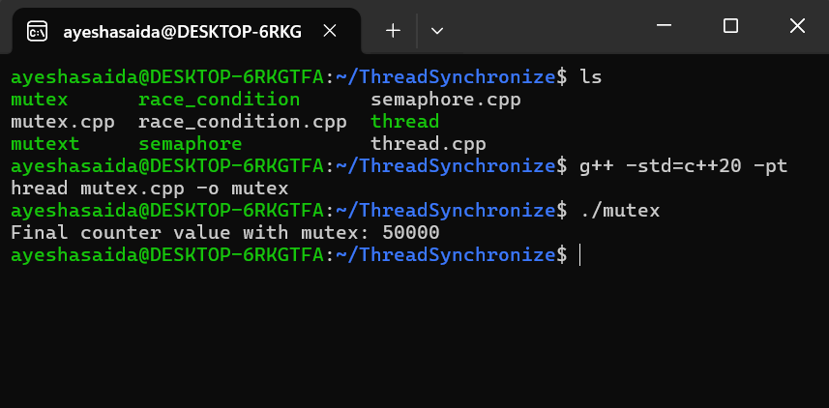

Code: using semaphore

#include <iostream>
#include <thread>
#include <vector>
#include <semaphore>
int counter = 0;
std::counting_semaphore<1> sem(1); // Binary semaphore
void incrementCounterSemaphore() {
for (int i = 0; i < 10000; ++i) {
sem.acquire();
counter++;
sem.release();
}
}
int main() {
const int numThreads = 5;
std::vector<std::thread> threads;
for (int i = 0; i < numThreads; ++i) {
threads.push_back(std::thread(incrementCounterSemaphore));
}
for (auto& th : threads) {
th.join();
}
std::cout << "Final counter value with semaphore: " << counter << std::endl;
return 0;
}
Screenshot:
